Road Curvature Model Optimization

**Abstract**

**Background**

In the United States, the prevailing standards for road design come from The American Association of State Highway and Transportation Officials, referred as the Green Book. This book offers an extensive review of road design considerations that comply with vehicle dynamic behavior. Special consideration is given to curve maneuvering because there are centripetal forces that need to be balanced with a combination of road factors to maintain vehicle stability. The dynamics are formulated using Newton’s Second Law of motion, which takes into consideration both road and vehicle characteristics. Road design parameters include, road friction, superelevation, and maximum width, while the vehicle parameters considered are velocity, acceleration, trackwidth, and vehicle length. These are summarized with the following formula:

Where:

Vehicle velocity (m/s)

Superelevation (as a percentage)

Gravitational acceleration (9.81 m/s2)

Coefficient of side road friction

Radius of curvature (m)

This formula relates most of the parameters that can be involved from any general vehicle and general street. In the case of street design, road friction and superelevation are already implemented on most roads. Vehicles can vary their velocity and heading accordingly as they traverse any curve. However, the factor that unites both the road and the vehicle is the radius of curvature. From geometric considerations and Newton’s Second Law, it is possible to find another equation that relates more vehicle parameters to the radius of curvature as follows:

Where:

Wheel directional angle (deg)

Radius of curvature (m)

Vehicle velocity (m/s)

L = Vehicle length (m)

Understeer gradient (deg-s2/m)

Since the Radius of Curvature belongs to the set of all real numbers, to avoid division by zero, the inverse function is used. This is known as Curvature and is depicted as follows: . Curvature is unique in the sense that every vehicle creates its own curvature when traversing any arbitrary road. However, all roads have already a pre-determined curvature that was designed for a variety of vehicles as discussed before. Furthermore, curvature can be directly related to a vehicle’s heading angle through an orthogonal shift for an instantaneous point in time. For this reason, being able to provide vehicles with this pre-determined curvature poses a new guiding factor that autonomous vehicle technology can implement into their decision algorithms for navigation. This in turn can improve their reliability under conditions where disruptions such as weather effects or poor lane markings disable sensor information.

There exist multiple types of roads in which curvature changes as a function of segment length to provide both stability and comfort to drivers. These are divided in two categories, horizontal and vertical curves. Horizontal curves focus on the direction of the centerline, while vertical curves focus on the slope of the centerline. Horizontal curves are divided into 4 main categories shown in Figure. For this project, only the 4 main horizontal curves are considered because they constitute most of the implemented roads available.

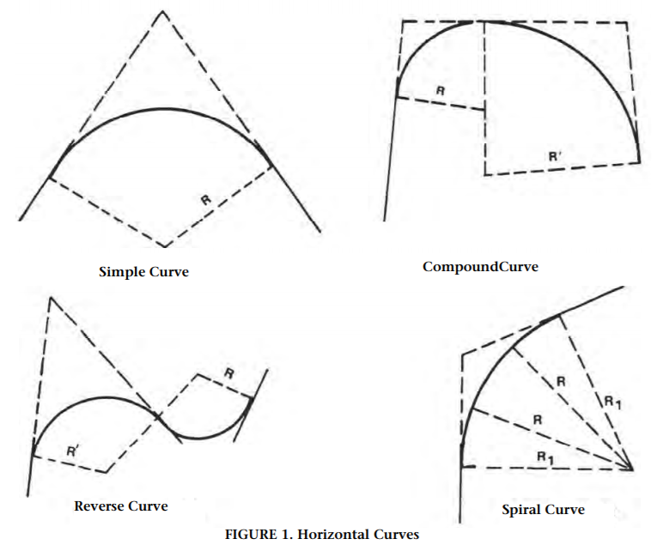

Thus, curvature models were developed that can represent these types of roads. However, to attain an optimized curvature model that can be applied to general vehicles. An optimization problem needs to be defined that utilizes both real road data and vehicle parameters.

**Optimization Problem Formulation**

To obtain the road data, a previous study has been performed which outputs the curvature values needed to be compared with the curvature models []. These models are subject to a Least Squares Error - Minimization problem such as:

Subject to:

Where:

Road curvature model

Road sampled curvature data

Previously defined vehicle constant parameters

Vehicle velocity

**Implementation**

**Results**

**Conclusions**

**Code**

MAX TEN PAGES 10

Mention different types of curves

Mention how aashto green book uses its own criterion to develop their design standards for friction

Usually these are made in a underestimated considerations (conservative values).

Mention how the values that we have try to find the optimal curvature and optimal travel velocity (because both velocity and heading angle are the only variables that we cant control during driving).

Some variables we cannot control:

Understeer gradient

Coefficient of Friction

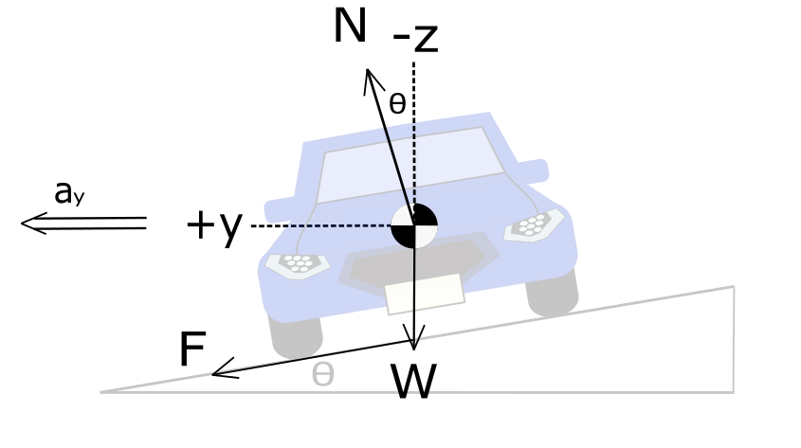

Jacome, R., Stolle, C. and Sweigard, M., “Road Curvature Decomposition for Autonomous Guidance,” SAE Technical Paper

2020-01-1024, 2020, doi:10.4271/2020-01-1024.